**STUDENT REPORT SYSTEM**

*A*

*Mini Project Report*

*Submitted in partial fulfilment of the*

*Requirements for the award of the Degree of*

**BACHELOR OF ENGINEERING**

IN

**INFORMATION TECHNOLOGY**

By

BASHETTI SANKEERTHANA <1602-19-737-099>

CHEMUDU SREEYA <1602-19-737-110>



**Department of Information Technology**

**Vasavi College of Engineering (Autonomous)**

**(Affiliated to Osmania University)**

**Ibrahimbagh, Hyderabad-31** **2020**

**Vasavi College of Engineering (Autonomous)**

**(Affiliated to Osmania University)**

**Hyderabad-500 031**

**Department of Information Technology**



**DECLARATION BY THE CANDIDATE**

We, **Bashetti Sankeerthana,** bearing hall ticket number, **1602-19-737-099**, and **Chemudu Sreeya ,** bearing hall ticket number , **1602-19-737-110** are hereby declare that the project report entitled **" Student Report System"** Department of Information Technology, Vasavi College of Engineering, Hyderabad, is submitted in partial fulfilment of the requirement for the award of the degree of **Bachelor of Engineering** in **Information Technology**

This is a record of bonafide work carried out by me and the results embodied in this project report have not been submitted to any other university or institute for the award of any other degree or diploma.

Bashetti Sankeerthana

1602-19-737-099

Chemdu Sreeya

1602-19-737-110

(Faculty In-Charge) (Head,Dept of IT)

**ACKNOWLEDGEMENT**

The mini project entitled **"STUDENT REPORT SYSTEM"** Is the outcome of total efforts of our batch. It is our primary responsibility to innovate the things , make people indulge in our project and have a relation with our project. Without home it would have not gained a structure.

I owe immense thanks to my project Guide Mrs.DRL. Prasanna, Assistant Professor Department Of Information Technology, Vasavi College Of Engineering for this sustained interest, constructive criticism and constant encouragement at every stage of this Endeavour.

Also, I whole heartedly thank Dr.T.Ramamohan Rao, Professor and Head Of Department, Vasavi College Of Engineering for his constant encouragement.

I extended my deep sense of gratitude to the Principal Dr.S.V.Ramana and the management of Vasavi College Of Engineering for providing of the best amenities to enable us to complete my project in stipulated time.

Last but not the least, I am very thankful to my parents, friends, faculty and other faculty of the department of Information Technology for their constant support for the completion of the project.

**BASHETTI SANKEERTHANA**

**1602-19-737-099**

**CHEMUDU SREEYA**

**1602-19-737-110**

**ABSTRACT**

The main objective of our project is to simplify the evaluation of final percentages and grades of the students which is done by the “FACULTY”. Basically ,where ever we go in the whole globe ,the first thing the other fellow being ask, is our “ EDUCATIONAL STATUS ”. So, we have decided a project called “STUDENT REPORT SYSTEM” .

The project “Student Report System” basically deals with the calculation of the percentages , grades and total marks of the student. This makes the work of the faculty easier, comfortable. .

The Report System contains the details of the Pupil and Every student information will be allocated in a file. Where they need to enter the roll no and password which accesses their document. Every time as they take examination, their new score will be appended into their respective file and new grade, percentage will be displayed. Along with examination dates and holiday dates will be acknowledged. This gives both the faculty and parents to have a brief idea about their ward’s performance.

**TABLE OF CONTENTS**

1.Introduction..................................................................06

2.Technology....................................................................08

3.Proposed Work..............................................................09

3.1.Design.............................................................09

3.2.Implementation...............................................11

3.3.Testing.............................................................15

4.Results............................................................................16

5.Additional Knowledge Gained......................................24

6.Conclusion and Future Works........................................25

7.References......................................................................26

## 1. INTRODUCTION

## ABOUT THE PROJECT

“STUDENT REPORT SYSTEM” is a console-based C Project which keeps the record of students of the institution. The program is run by the faculty who can add, record, modify, delete, generate marksheet, update_credentials , get examination_dates, get Holiday_dates and find records according to the need.

## 1.1 PROJECT DOMAIN

## 

The Student Report System is a very common task for any School Institution. Though the method differ from organization to organization. The Student Report System of the earlier times had a manual system using ledger books to keep track of every single student marks history, calculate their total and percentages. This pen and paper based system in much time consuming and there is a great chance to make mistake as there are very good number of student in the organization and keeping patience is a tough job to manipulate so many things .

**Purpose**

The Main aim of developing this project is to provide an easy way to access full functional reports of student with necessary details. Nowadays large scale organization are committed to bring the best way of management in the various forms .

**Benefits**

* To improve efficiency.
* Quickly find out information of a student details.
* To provide easy and faster access information.
* To provide user friendly environment.

**1.2 FEATURES**

In this project the faculty can add, record, modify, search, generate marksheet ,update_credentials and delete the records of student. And also get the examination dates and holiday dates of the academic year.

**1.2.1 Add Records**

The faculty add the records of the information of student.

**1.2.2 Search Records**

The faculty search the details of the student.

**1.2.3 Modify Records**

The faculty can modify the details of the student according the requirements of the student.

**1.2.4 Delete Records**

The faculty can delete the record of the student according to requirements of the institution.

**1.2.5 Generate Marksheet**

The faculty can generate the marksheet of the respective student depending on their academic performance and give the percentage.

**1.2.6 Update Credentials**

The faculty can update the credentials of the student according to the requirements.

**1.2.7 Get Examination Dates**

The institution acknowledges the student regarding the examination dates of the academic year.

**1.2.8 Get Holiday Dates**

The institutions acknowledges the student regarding the holiday dates of the academic year.

**2.TECHNOLOGY**

All computer software needs certain hardware components or other software resources to be present, in order for computers to be used efficiently. These prerequisites are known as System Requirements. Within this, we have two types – Software Requirements and Hardware Requirements.

## SOFTWARE REQUIREMENTS

Software Requirements deal with defining the software resource requirements and prerequisites that need to be installed on a computer to provide optimal functioning of an application. These preconditions are generally not included in the software installation package and need to be installed separately.

In order to use CODIAC, one should have the following:

* **Operating System:** Windows 7 and above
* **C Compiler:** GNU Compiler Collection (GCC)
* **Editor:** Any text editor .

**HARDWARE REQUIREMENTS**

Hardware requirements refer to the common set requirements defined by any operating system or software application and are usually the physical computer resources. In this, we look into the architecture, processing power, memory, secondary memory, display adapter and peripherals.

In order to use this project, one should have the following:

* + - **Processor:** Intel Pentium processor and above
    - **Memory:** 4 GB RAM and above

**3.PROPOSED WORK**

**3.1.DESIGN**

Our approach in designing STUDENT REPORT SYSTEM was to divide our users into two groups-the students and the faculty. The faculty is a day_to_day consumer whose goal is to provide a safe and friendly environment in adding searching deleting updating credentials of a student and generating holidays, marksheet report .The Student’s end goal is to view their record in the database. Students can also approach their respective faculty for any changes concerned.

**3.1.1 USE CASE DIAGRAM**



**3.1.2.Flow Chart**

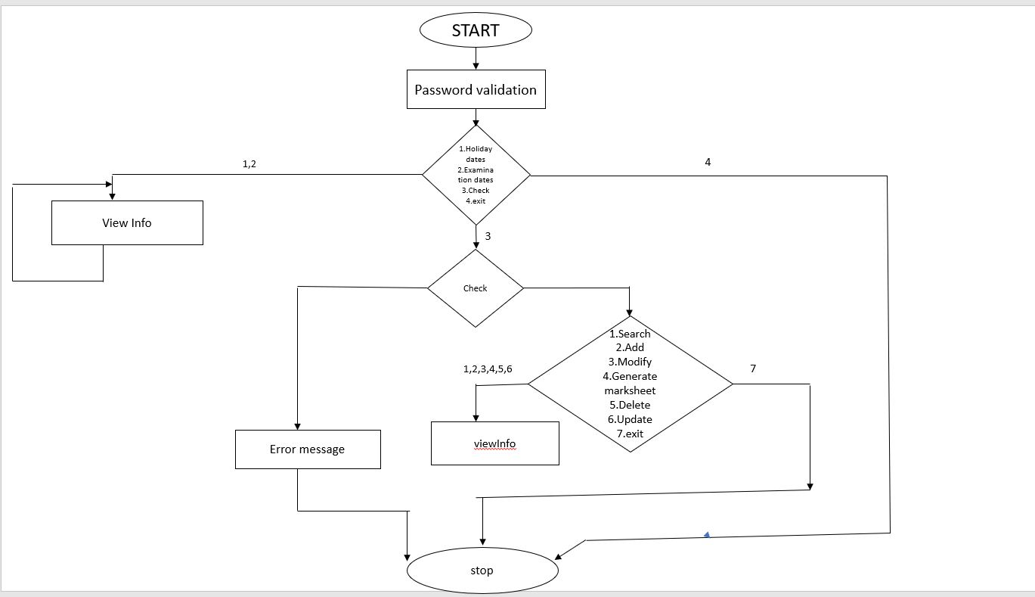

**3.2.IMPLEMENTATION**

**3.2.1.** **Description of main modules**

Based on the use cases, we have implemented this project by dividing the work into modules – Login, Get Holiday Dates, Get Examination Dates,Add Record, Search Record, Modify Record, Delete Record, Generate marksheet, Update Credentials and Exit is to terminate the application

**3.2.1.1.LOGIN**

In order for a user to login to STUDENT REPORT SYSTEM, he/she must be registered user. First, the system will prompt the user to enter his/her credentials. Once, the user enters his/her credentials, we check whether it matches with the information in the database. If a match is found, the user gets access to STUDENT REPORT SYSTEM.

**3.2.1.2.GET EXAMINATION_DATES**

The user can choose any of the summative exam dates. After choosing the respective summative dates can be viewed.

**3.2.1.3.GET HOLIDAY_DATES**

The user can choose any of the month to view respective holiday dates in that academic year. Which gives the list of holiday dates in that particular month.

Here there will be a user check. This check confirms whether the logged in user is a faculty or student. The faculty will be having a secret code which allows them to go for further process

**3.2.1.4.ADD STUDENT**

The teacher have to add the records of the student. Teacher can add the details of student like name, id, address ,parent’s name ,class, phone number. And the institution of our project designed for 1-10 classes.

**3.2.1.5.SEARCH STUDENT**

The teacher can search the details of the student by entering the id of the respective individual . If the record doesn’t exist for the id entered then it does not display any details on the screen. If the records exist it displays the respective details on the screen

**3.2.1.6.MODIFY STUDENT**

The teacher can modify the details of the student like name, id, parent's name ,address, class, phone number using the past id. If the records were exist. Otherwise it gives an error message.

**3.2.1.7.UPDATES CREDENTIALS**

Teacher can also update the credentials of the student by choosing update credentials. After choosing, it asks whether to proceed or not. if you choose yes ,then it asks for a new password. Soon you enter the password it returns to the main menu. Else it returns to the previous window

**3.2.1.8.GENERATE MARKSHEET**

Upon opting generate marksheet. Details of the student are entered by the teacher like roll no and name. After filling the basic requirements, respective subject marks need to be entered by the teacher. Soon after entering, the percentages; Total marks grades gets calculated and are written into the file.

**3.2.1.9.DELETE STUDENT**

Teacher can delete the record of the student based on the requirements like id. If the record exists then it displays a message that it got deleted successfully. Otherwise, it displays an error message

**3.2.1.10.EXIT**

The teacher on choosing the exit option the program gets terminated.

**3.2.2. SPECIFIC ALGORITHM/LOGIC**

**3.2.2.1.GENERATE MARKSHEET**

void generate_marksheet() //generate_marksheet function

{

clearWindow();

print_heading("Marksheet");

SetColor(45);

system("cls");

char name[25],divission[10];

FILE *fp;

fp=fopen("marksheet.txt","ab+");

int x=37,sub1,sub2,sub3,sub4,sub5,sub6,total,percentage;

gotoxy(37,10);printf("Enter the Roll No : ");fflush(stdin);

gets(stu_marks.roll_no);

gotoxy(37,12);printf("Enter Name : ");

fflush(stdin);

gets(stu_marks.name);

gotoxy(x,14);printf("Enter Subject Marks :\n");

gotoxy(x,16);printf("Enter Telugu Subject marks:");gets(stu_marks.sub1);

sub1=atoi(stu_marks.sub1);

gotoxy(x,18);printf("Enter Hindi Subject marks:");gets(stu_marks.sub2);

sub2=atoi(stu_marks.sub2);

gotoxy(x,20);printf("Enter Social Subject marks:");gets(stu_marks.sub3);

sub3=atoi(stu_marks.sub3);

gotoxy(x,22);printf("Enter English Subject marks:");gets(stu_marks.sub4);

sub4=atoi(stu_marks.sub4);

gotoxy(x,24);printf("Enter Math Subject marks:");gets(stu_marks.sub5);

sub5=atoi(stu_marks.sub5);

gotoxy(x,26);printf("Enter Chem Subject marks:");gets(stu_marks.sub6);

sub6=atoi(stu_marks.sub6);

total=sub1+sub2+sub3+sub4+sub5+sub6;

itoa(total,stu_marks.total,10);

percentage=(total/600)*100;

itoa(percentage,stu_marks.percentage,10);

fwrite(&stu_marks,sizeof(stu_marks), 1, fp);

gotoxy(x,28);printf("\n\t\t\t\t\t\tThe data is registered sucessfully!!!!!\n");

system("cls");

fclose(fp);

SetColor(28);

}

**ALGORITHM**

* In generate marksheet, firstly particular student roll no is entered.
* Then file is declared and opened in append mode.
* Now the 6 subject marks are entered accordingly by the teacher. In order to append in to the file these marks are converted using atoi function.
* Atoi function is used to convert the string to an integer and is stored in another identifier.
* These subject marks are added and stored in the total. Total is calculated by summing up all subject marks. Itoa function is used to convert integer total to a string total.
* Now percentage is calculated subsequently and stored in the marksheet file.
* System cls helps in clearing the window screen and followingly file get closed successfully using the fclose operation.

**3.2.3.Github Links**

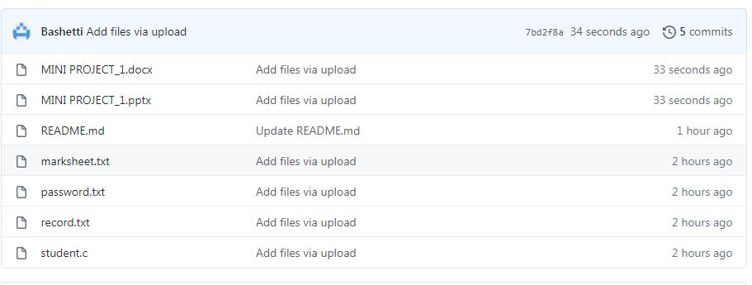

**3.3.TESTING**

Test Case 01

In the login system, we will have only three chances in order to get into the further process. If in any of the three chances, if the user enter correct password then he/ she can access it. If he fails to do that then he/ she cannot access further.

Test Case 02

In the get examination dates, the user can only have three kinds of examination. If the user enters wrong input then invalid input will be displayed.

Test Case 03

In get holiday dates, the user can enter between 1 to 12 months and 13 for exit. If the user tend to enter other input, the invalid input will be popped out.

Test Case 04

The user can be student or teacher. So in order to differentiate between them, the teacher should enter a code with numbers in order to go through further process. The teacher can only handle the other modules like add student, search student, generate marksheet etc. The student cannot do that and if the student tries to do , in that case the message " INVALID USER" will be popped up.

TEST CASE 05

The teacher can only have an option to select among 1 to 7 for accessing the modules. The other entry of inputs will not be considered.

**4.RESULT**

**4.1.Login**

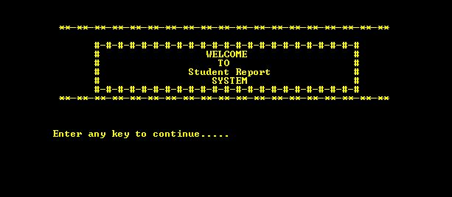

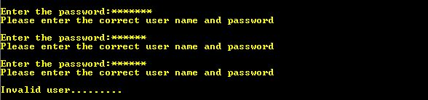

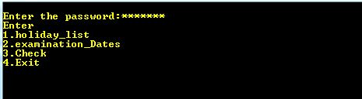

**4.2.Get Examination Dates**

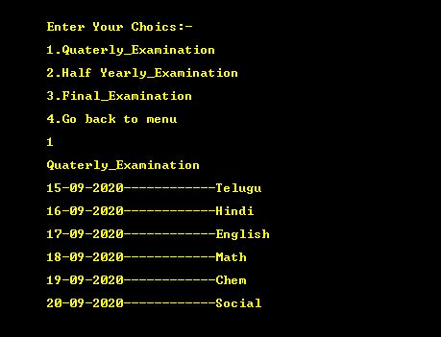

**4.3.Get Holiday Dates**

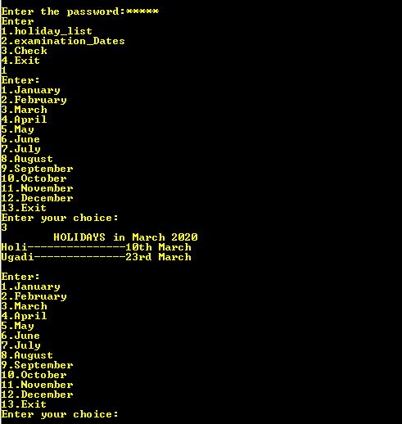

**4.4.Add Student**

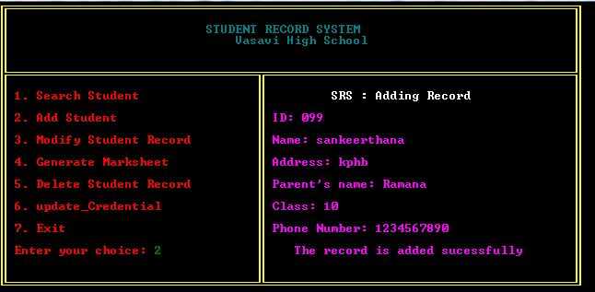

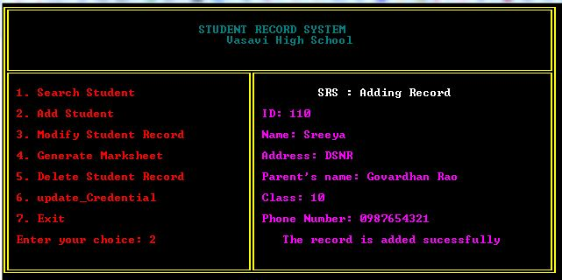

**4.5.Search Student**

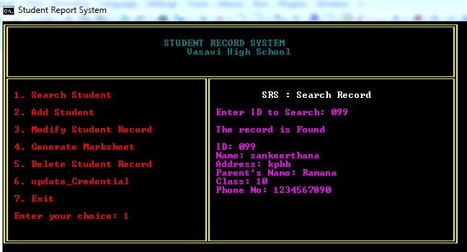

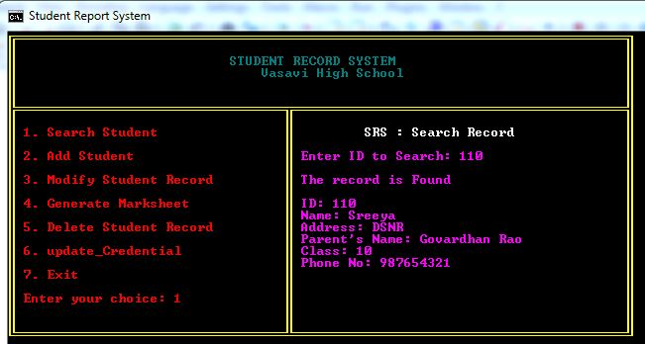

**4.6.Modify Student**

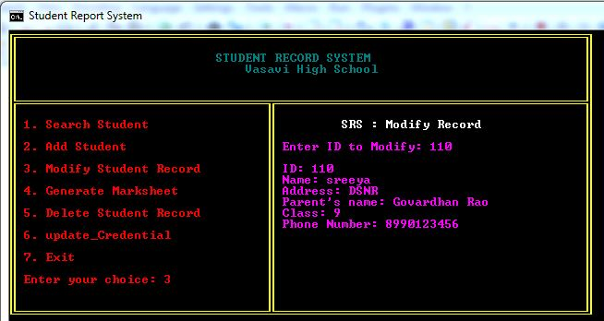

**4.7.Update Credentials**

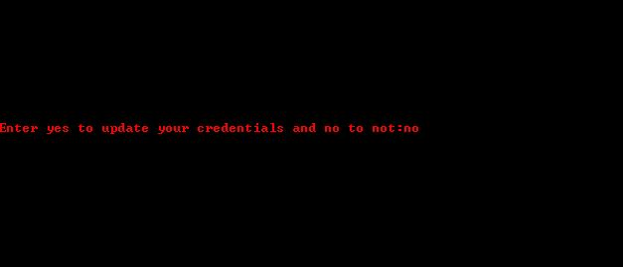

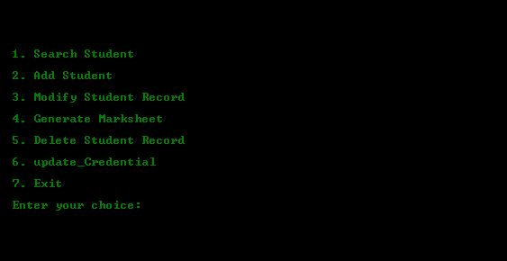

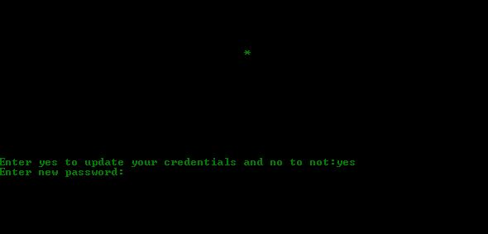

**4.8.Generate MarkSheet**

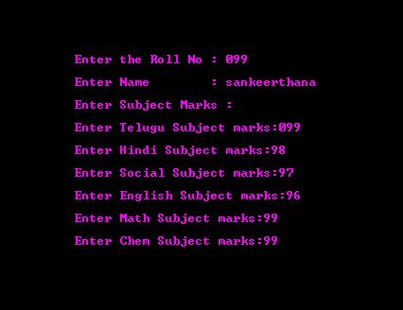

**4.9.Delete Student**

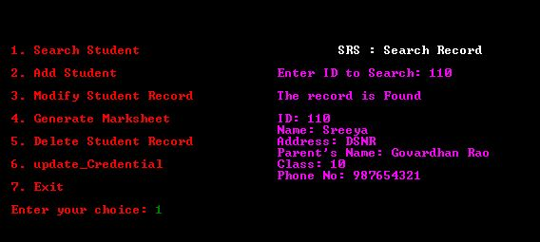

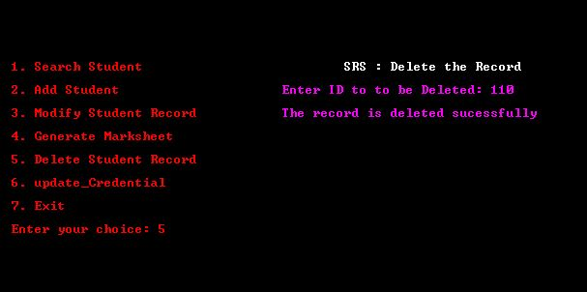

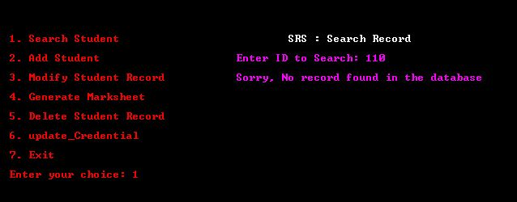

**5.ADDITIONAL KNOWLEDGE GAINED**

Implementing this project in C Language has introduced us to different libraries such as: ‘conio.h’, ‘time.h’ and ‘windows.h’. We used the ‘windows.h’ library for controlling the display colours in a controlled manner. We explored the ‘time.h’ and ‘conio.h’ libraries for achieving a look-and-feel of an actual window application by constructing our own color function.

Also, we have further improved our knowledge in file-handling because of the vast amount of data manipulation we have done using text files.

Other than this, we have learnt the value of team spirit and have understood the intention behind working in teams. We have learnt to be team players.

**6.CONCLUSION AND FUTURE WORKS**

To conclude, this application is useful for educational institutions. It triggers user- friendly operations.Our Future work is to develop the application in PHP Or HTML to make this console application as a web application. And also develop using DBMS to increase the scope.

**7.REFERENCES**

* C Language Documentation: [https://docs.microsoft.com/en-us/cpp/c- language/?view=msvc-160](https://docs.microsoft.com/en-us/cpp/c-language/?view=msvc-160)
* Visual Studio Code:
* Stack Overflow (for debugging errors): <https://stackoverflow.com/>
* https://www.geeksforgeeks.org/csv-file-management-using-c/